Onstage in the Speirs Centre
March 14 - 23
2024
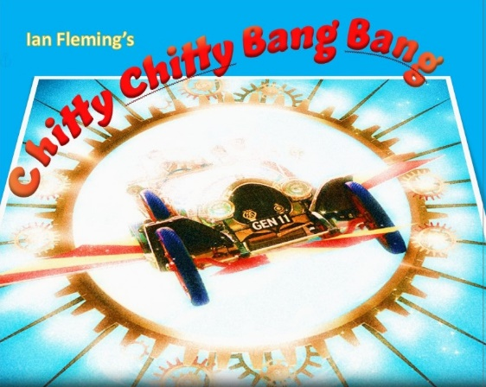

Contents:
Section 1 Our vision, the management team
Section 2 Applications, Crew, musical accompaniment and understudies
Section 3 Some changes: health and costs
Section 4 Our expectations of Company members
Section 5 Term 4 workshops, auditions and rehearsals
Section 6 Term 1 2024
All audition material is available on the Company Information page on our website

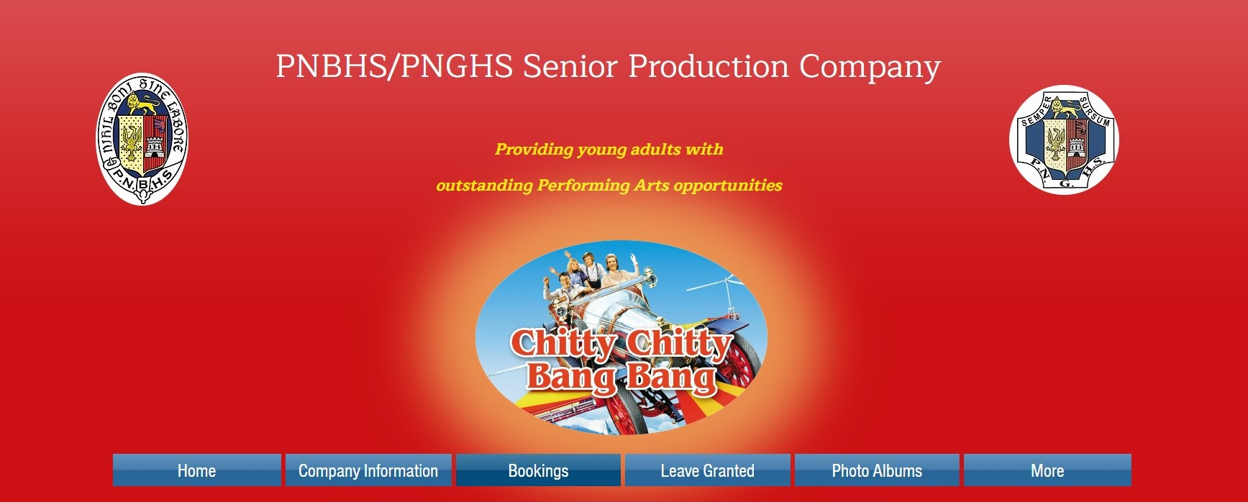
Section 7 A few tips!

www.pnbhspnghsproduction.com

Like us on Facebook:
- PNBHS/PNGHS Senior Production Company Facebook group. This group is open to all current and past Company members and our supporters.
This website is best viewed on a computer. However, you can use your phone.
- All Company members and/or a parent/caregiver will be required to join the closed Facebook group PNBHS/PNGHS Chitty Chitty Bang Bang 2024 which will be our main means of communication.

Section 1: our vision, the management team

PNBHS/PNGHS Senior Production Vision Statement:
1 to provide onstage and offstage artists with the opportunity to achieve collective and individual performance excellence, by participating in a safe and productive team environment where their skills are developed and their senses of achievement and enjoyment are high.

2 to deliver to the audience a production that is of a high standard due to the successful integration of well-planned and well-rehearsed production components: technology, music, dance, singing, acting, speaking, promotion and sales.

How do we achieve this? By putting TEAM FIRST: musical theatre is an intensely co-dependent activity and ALL DECISIONS WE MAKE WILL BE BASED ON WHAT IS BEST FOR THE TEAM. In a team of around 100 students and adults, selflessness and sacrifice will be required from ALL of us to ensure we reach our combined goal of excellence. The responsibility for that comes down to us all as individuals. If you wish to audition, your first responsibility is to make sure you and your whanau completely understand what will be expected of you, if you choose to proceed and are selected.
Management will provide an environment which is safe, collaborative and supportive. Anyone who challenges our ethos may be stood down from the Company. TEAM FIRST.

Production Management Team:
Director: Sophie Coetzee
Assistant Director: Chris Burton
Production Manager: Nikolas Kearns
Vocal Director: Kirsten Clark. Assistant: Lindsay Yeo
Choreographer: Tamzin Price. Assistant: Leanora Potten
Musical Director: Lottie Perry
Stage Managers: Tristan Little and Riley Best
Costume Director: Jess Cave
Props Director: TBC
Makeup and Hair Directors: Kelly Pfeffer-Marshall and Angie Baines

Section 2: Applications, musical accompaniment and understudies

The Cast application form is on the website, with applications now open, and closing Term 3 Week 10 on Friday 22nd September.
The Crew application form is on the website, with applications now open and 4 Week 3 on Fri Nov 4.
Musical accompaniment
We are staging this musical theatre without live accompaniment. This is solely to reduce potential complications from illness absences. We have purchased top class backing tracks from Musical Theatre International and Lottie Perry, who has significant experience as MD with Act 3 Productions, will be driving their use and co-ordinating with Vocal Directors, Kirsten Clark and Lindsay Yeo.

THE CREW
The Crew application form is on the website, with applications now open and closing Term 4 Week 2 on Friday 20 October. For future productions, we want to develop our base of keen, reliable technicians, including trainee Stage Managers, and will train students as necessary. Selection will be conducted by our Stage Managers in consultation with Mrs. Coetzee and Mr Burton.
Application forms are available on the Company Information page of the website.

Understudies
Due to the ongoing effects of illness, we will be selecting understudies for more roles than usual, again, from cast who are keen to accept the extra workload and whom, we believe, demonstrate the necessary commitment to develop the confidence and ability to perform these roles. It is a fantastic development opportunity. If understudies reach our performance standard, they are guaranteed a performance in that role. For many years, all of our understudies have done so.

Section 3: Some changes: health and costs

Section 4: our expectations of company members
What are our expectations?
- You will be required to make Chitty Chitty Bang Bang your NUMBER ONE CO-CURRICULAR COMMITMENT FOR TERM 1 2023 which includes sports/cultural activities, jobs, other entertainment events, social, family and church activities.

- Leave can only be applied for from Mrs. Coetzee, and granting it will always be at her discretion, taking into consideration what is best for the team.

- Excepting illness, emergencies and school trips, it is unlikely Mrs C will consider leave from rehearsals in 2024 unless it has been applied for, for a significant reason, before the end of Term 4, 2023. But, GOOD COMMUNICATION IS EVERYTHING and if it does not affect the team adversely, she will consider it.
Parents, please do not purchase Xmas gifts that would encroach on our published production rehearsal time.

Health
The recent upsurge in contagious illnesses has forced us into a change regarding Makeup. All cast will be required to supply their own basic makeup products for all skin contact applications. This need not be expensive and in Term 4 we will provide you with a basic list. Should the need arise, we may arrange a basic kit you can purchase. A sealable, named individual container will also be required.

Costs
Due to rising costs (It will cost $45-50,000 to stage Chitty Chitty Bang Bang), this year we have added a new requirement that cast assist with the cost of making, hiring and washing costumes. This will be $30 per cast member.

If payment is likely to be a problem, please contact Mrs Coetzee before auditions.
Expectations continued…

- Advertised rehearsal times are our start times – you are expected to arrive 5 minutes early and be ready to start at these times.

- Learning lines is something actors do in their own time – rehearsals are for putting the show together. All lines, lyrics and previously taught choreography must be learnt before we restart in late January 2024.

- If you are experiencing any difficulties in meeting our expectations (this might be due to workload, stress or other unexpected circumstances) you should discuss this IMMEDIATELY with Mrs Pomana-Whale (b.pomana-whale@pnghs.school.nz) /Mrs Kensington/Mrs Price/Mr Samia at PNGHS or Mrs. Coetzee or Mr Burton at PNBHS. Please do this early so that we can work with you to achieve a satisfactory outcome.

- Absence without leave, repeated lateness or inappropriate behaviour are likely to result in dismissal from the company.

- As this is a school production, school rules apply to all aspects of its preparation and performance with particular reference to use of vehicles, vape, tobacco, alcohol and drugs, AND use of devices and online material. Phones are never carried onstage and from the commencement of Dress Rehearsals, will be handed in by 30 minutes before curtain-up. They will be returned at the conclusion of the run.
By signing the application form, students and parents/caregivers are confirming that you understand, and agree to meet our expectations, and the commitments required.

IF YOU DON’T ACCEPT THEM – PLEASE DON’T SIGN!!

Section 5: Term 4 workshops, auditions and rehearsals

Rationale: the process we have used successfully for many years is designed to give every cast auditionee the best possible chance to gain confidence with the management team, our environment, your peers and the audition material, before your formal audition.

We audition for the overall cast first, and, based on what we have seen and heard from them, we select those we would like to audition for major roles. If students feel they have been overlooked for major role auditions, we will consider their request based on what we have seen to that point. There is a compulsory Dance workshop/audition for all cast, followed by a separate workshop and audition for principal Dancers. Minor roles are appointed.

If you are keen to audition but foresee time management difficulties in
Term 4 due to prior commitments, talk to Mrs Coetzee BEFORE auditions.
We sometimes make exceptions to ensure we have the best possible skills available to the team. Mrs C’s contact details are at the end of this document.

GOOD COMMUNICATION IS EVERYTHING!!
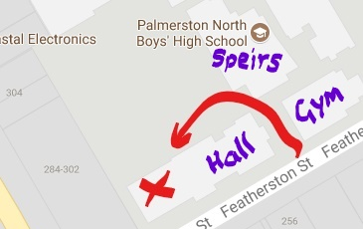

In Term 4, most cast workshops, auditions and rehearsals will take place in the PNBHS Drama (H) Block. Walk along beside the tennis courts to the rear of the Ian Colquhoun Memorial Hall.
Getting ready for workshop auditions
1 Check the Company Information page on the website at www.pnbhspnghsproduction.com
2 Print and bring all docs relevant to any roles you are workshopping or auditioning for – we will use the same for both. Everyone will need Ensemble material. Those who have not bothered to do this are telling us that following our instructions is not that important to them and/or they are poorly organised. Not a great start to selection chances.
3 You are NOT expected to learn workshop/audition material by heart. However, it will help you to come with a good working knowledge of the dialogue/number excerpts.
4 Workshops are NOT compulsory, but are highly recommended. Attend as many as you can to get full advantage of our coaching, but you are not required to attend them all. They will cover all the audition material for Ensemble but sometimes we try extra material with principal auditionees.

Week 1 Term 4 2023 PNBHS H Block
Day | Time and Place | What
Mon 9  Oct | 4-540pm  H Block | ENSEMBLE WORKSHOP 1 Dialogue only.  We value students who are:  - ON TIME  - PREPARED  - RESPECTFUL of EVERYONE  Open to everyone Strongly recommend attending.  Groups will rotate through 3 rooms for a variety of readings.  Reminder: Print these excerpts from the website and bring them with you. Dialogue excerpt #s 1,3,4,7  Truly, Potts, Jemima, Jeremy, Coggins dialogue. (Exerpt #1)  Baron, Baroness dialogue (Excerpt #3)  Boris and Goran (Excerpt #4)  Potts, Goran, Boris, Violet, Sid, Turkey Farmer (Excerpt #7)
Tues 10 Oct | 4 -6pm  H Block | ENSEMBLE WORKSHOP 2 Singing AND Dialogue.  Open to everyone Strongly recommend attending.  Groups will rotate through 3 rooms for a variety of dialogue readings AND singing  Dialogue excerpts #s 1 and 7  Singing – Chitty Chitty Bang Bang, Vulgarian Town Square
Wed 11 Oct | 4.00-6pm  H Block | ENSEMBLE WORKSHOP 3 Singing and Dialogue  Open to everyone Strongly recommend attending  Same format as Workshop 2  Dialogue excerpts #s 1, 5 and 7 with you today.  Singing – Chitty Chitty Bang Bang, Vulgarian Town Square  Truly, Potts, Jemima, Jeremy, and Coggins dialogue. (Exerpt #1)  Toymaker, Potts, Truly, Childcatcher, Soldier (Exc # 5)  Potts, Goran, Boris, Violet, Sid, Turkey Farmer (Excerpt #7)
Thurs 12 Oct | H Block  3.30 – 3.50  3.50 – 4.10  4.10 – 4.30  4.30 – 5.00  5 .00 – 5.30 |  | PRINCIPAL WORKSHOP Singing only  Anyone wanting to be considered for a Principal role/Understudy should attend  Print and bring the relevant lrics  Singing: Grandpa - Posh  Singing: Baron/Baroness separate and together. Chu Chi Face  Singing:Boris/Goran separate and together. Act English  Singing: Jeremy/Jemima/Potts separate and together. You Two reprise and Truly Scr.  Singing: Truly/Potts separate and together. Doll on Music Box

Week 2 Term 4 2023
Sun 15 Oct | 9.30-11.30  11.45-12.45 | COMPULSORY DANCE SESSION – ALL auditionees required – Old Gym  Principal Dancer workshop and audition – Little Theatre  Reminder: Fill in your Ensemble audition slot (on the Senior Production notice board in H Block). Auditions are in MIXED gender groups of 6-8. You attend ONE 20-minute session in a slot of your choice.
Tues 17 Oct | 4 -?  H Block | ENSEMBLE AUDITIONS  - Everyone must attend at the time they have selected  - Dialogue reading: Excerpts #s 1 and 7.  - Group and solo singing: Chitty Chitty Bang Bang, Vulgarian Town Square
Weds 18 Oct | Morning  3.30 – 4.00  4.00-4.45  4.45- 5.30  5.30-6.15 | Full cast and those selected to audition for soloist/principal/understudy roles posted in both schools, FB and website. If you feel you have been overlooked for a principal/understudy audition contact Mrs. C, ASAP.  PRINCIPAL WORKSHOP AUDITION Dialogue and singing  For selected students only - Roles will be cast at any stage from today on – as soon as we are sure we have the right person. In workshops we will be constantly reducing numbers for each role. This is why it is very important that you attend the workshops. Principals and understudies who are cast are required to stay and read/sing their part for following auditions.  Reminder: Bring with you relevant dialogue and lyrics.  Dialogue #2 Grandpa, Baron  Dialogue #4 Boris, Goran (Females welcome)  NOTE: The Child Catcher does NOT have a solo singing part.  Singing Act English  Dialogue #3 Baron and Baroness  Singing Chu Chi Face  Dialogue #1 Jeremy, Jemima, Potts, Truly, Coggins  Singing CCBB and Truly Scrumptious
Thurs 19 Oct | 3.30 – 4  4.00-? | Dialogue #5 Childcatcher, Toymaker, Potts, Truly, Soldier  Confirmation for other callbacks today will be made on Wednesday evening and posted on FB.
Week 3
Sun 22 Oct | 11-1.30pm | Little Theatre: Cast read-through. Bring lunch. There will NOT be time to leave the school.
Week 4
Sun 29 Oct | 9.30 – 11am  11.15 – 1.30 |  | ALL cast for dance in the Old Gym.  Bring food and water!  ALL cast for singing in The Little Theatre
All Sundays from today to Dec 10, Dance 9am (Old Gym)
then Singing till 1.30pm (Little Theatre)

The rest of 2023
- On Wednesday Dec 20 and Thursday Dec 21 ALL PRINCIPAL ROLES/Understudies will be required to be available from 930am – 3pm for blocking. A detailed sched will be posted on the website showing who is needed when on these two days. NCEA exams finish on Thursday 30th November.
- There are no further rehearsals until late January (see below) but all cast and band are expected to learn lines and parts and retain all they have been taught, over the summer break.

If you have a commitment already organised for any rehearsal times in Term 4 (including school trips or camps) you must ask for leave from Mrs. C before auditions. Otherwise, excepting illness and emergency, you will be expected to attend all rehearsals you are called for.
Section 6: Term 1 2024
- Weds 24/1 and Thurs 25/1 some roles and all Principal Dancers will be called for 4-7pm.
- Sun Jan 28 ALL CAST 12.30-5pm.

ALL CAST are required to be available for all scheduled rehearsals and performances from Sunday Jan 28.
ALL CREW must attend one Safety/Training session: 9.45-11.45am or 12.15-2.15pm
- From Jan 28, for Weeks 1-3, standard rehearsals will be:
Mondays 4-7pm Thursdays 4-7pm Sundays and Waitangi Day 12.30-5pm
Individual cast will not always be required for all these times but must be available if called on the detailed 3 week rehearsal schedule posted by Jan 26 which will say who is needed where, when and for what, within these times.
- From week 4, rehearsals are more frequent and/or longer and we will follow the production Timeline through to packout.
- Aside from rigging lighting and performances, we keep Fridays, Saturdays and Sunday mornings free for the Company, barring emergencies.
- Note there is ONE Production Day during the school day. This is Week 4 Mon Feb 19. Those required will be notified at least a week before.

ALL PERFORMANCE DATES ARE ON THE 2024 TIMELINE.

Section 7: a few tips!

To ensure all aspects of your year get off to a positive start, effective time management and forward planning will be essential at the start of 2024. Participation in Chitty Chitty Bang Bang will not be an excuse for poor academic performance. A homework room will be available throughout rehearsals in Term 1 2024.

Please remember TEAM FIRST will form the basis of every onstage and offstage decision the management team will make. For example, it will guide suggestions we may make at workshops and auditions about how we see your individual talents best fitting our production concept; don’t be disappointed if they are not what you first thought - it is not a personal criticism but, as with being selected in a different position in a sports team, an opportunity for you to extend yourself in new ways. Similarly, different roles have different requirements and being a lead in one show does not mean you are automatically selected, or a lead, in the next.
We unashamedly favour people who:
- clearly support our team goals and expectations
- behave appropriately
- are polite and friendly to everyone
- read and follow the instructions we have issued
- are well-organised, punctual and reliable
- show respect for others and work co-operatively
- show initiative and help out where they can
- are positive team players and want to excel!
- do not renege on the commitment they have made

Enthusiasm, punctuality, reliability and communication are everything. Sometimes we find space for one or two whose enthusiasm, energy and team commitment are more obvious than their performance ability!!
Should you or your parents/caregivers wish to discuss any matter, please contact the Director, Mrs. Sophie Coetzee: coetzees@pnbhs.school.nz Mobile: 0221296772
or Assistant Director, Mr. Chris Burton burtonc@pnbhs.school.nz Mobile: 027 6237 395

Decision checklist
- Read and highlight this doc
- Talk to family
- Consider your other commitments
- Apply by
- If unsure communicate with Mrs. Coetzee or Mr Burton BEFORE workshop/auditions

If you decide to go ahead:
- Check the schedule carefully
- Print material you will need from the website on the ‘company information’ page.
- Get familiar with the relevant script excerpts and music
- Practise an English accent

Our workshop/audition motto is
GET UP! GET SEEN!
GET HEARD!
(If you don’t, you have no chance of being selected)

We Will Be Awesome!!
Semper sursum NIHIL BONI SINE LABORE

