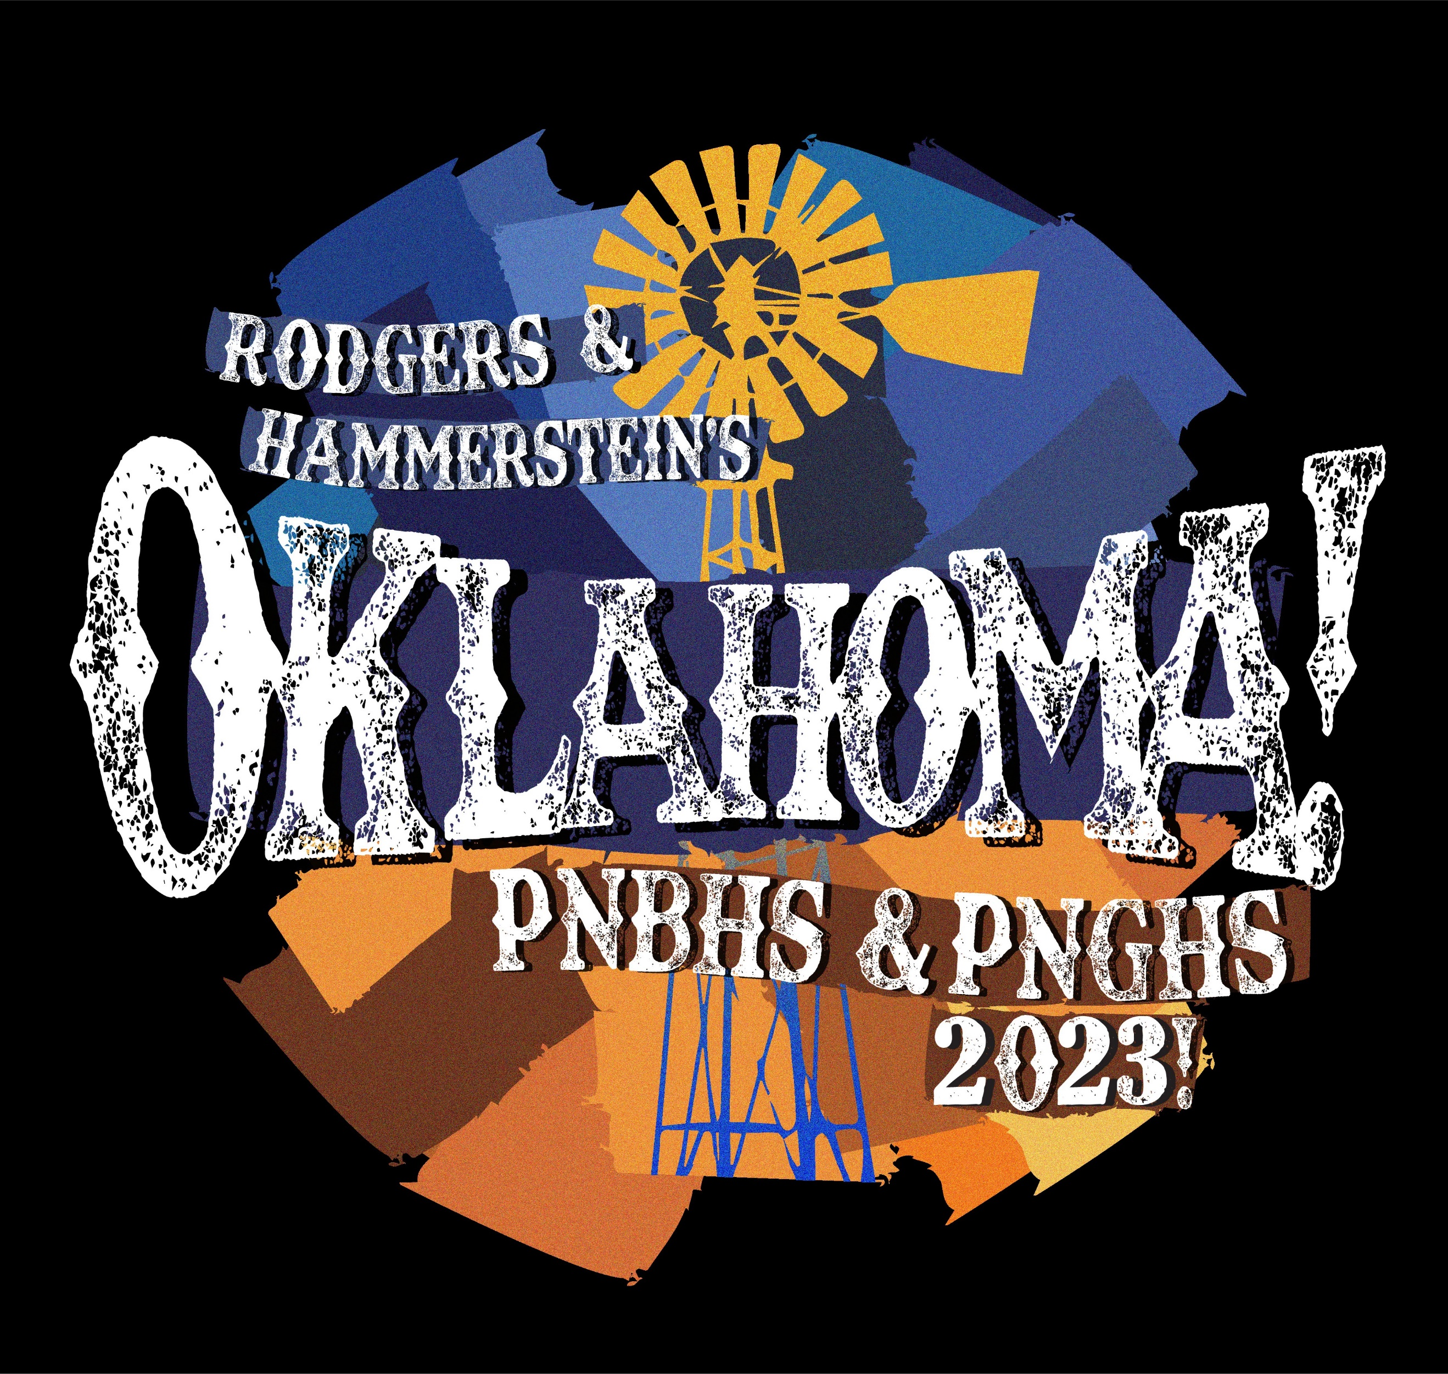

Booking complimentary and school discount seating
Please check which category you are in and follow those steps.
Bookings are already moving very well so we are making a deadline for booking complimentary seats 4pm on Monday Feb 27 and school discounts at 4pm on Friday, March 3. After that, seats will be released for sale and we cannot guarantee their availability.

Category 1 – Complimentary seats only
Please request your seats via Pam Marks: marksp@pnbhs.school.nz before 4pm on Monday Feb 27. She will arrange and confirm your booking with you, and your tickets will be available at the door on the night.

Category 2 – Complimentary seats + extra paid seats sitting together
Again, please request your complimentary seats and the types of paid seats (Adult, School age, Family 4 seat Pass) via Pam Marks: marksp@pnbhs.school.nz asap. She will arrange and confirm your booking for you.
You must then pay for the extra seats by 4pm on Monday Feb 27 or they will become invalid. Please pay at the PNBHS Finance Office and collect all your seats at the same time
If you pay by credit card there is a service charge.

Category 3 – SCHOOLS
School discounts for matinee performances on Tues 21/3 and Weds 22/3 at 530pm
Pricing: Students $12 + one free teacher for every 10 students
Please book your seats via Pam Marks marksp@pnbhs.school.nz asap including numbers of students and adults. She will sort your booking and email confirmation back to you.
You must confirm numbers by 4pm on Friday March 3 or the booking will become invalid. The numbers confirmed by 4pm on Friday March 3 are those which you will be invoiced for.

